***Lab 6: Database first with Entity Framework***

*Create a New MVC Application: File > New > Project > Then follow the steps in the image and click on OK button*

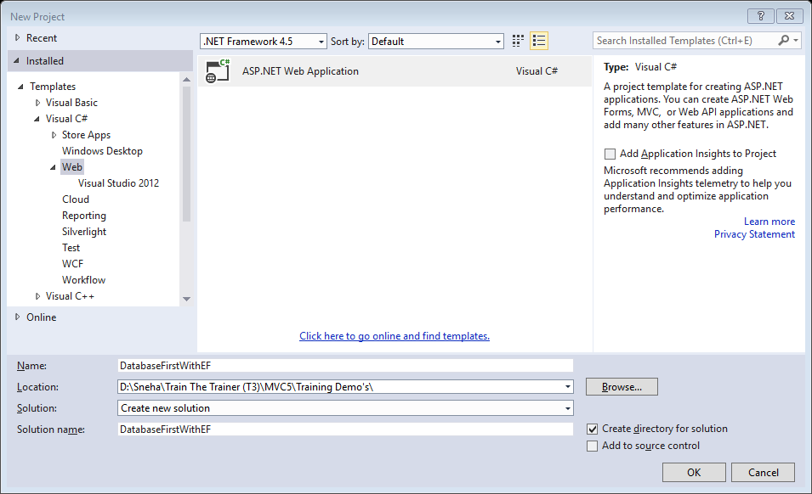

*Add new database: Right click on the project >Add > New Item >then follow the steps in the image and click on Add button*

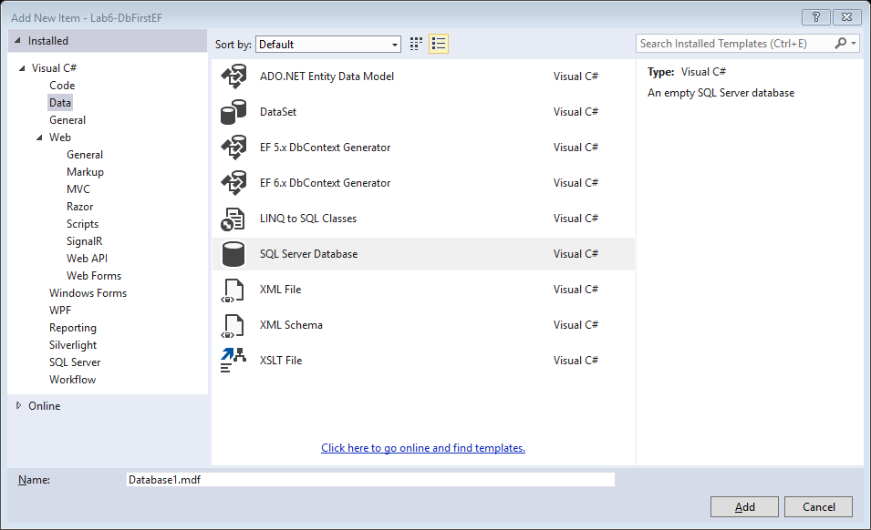

*Add new Table: Right click on the Tables folder under database in the Server Explorer > Add New Table > Write the following query for creating the table:*

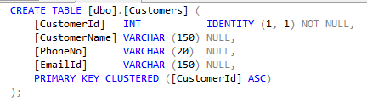

*Add ADO.NET Entity Model: Right click on the project in the solution explorer > Add > New Item > Follow the steps in the Image and click on Add button*

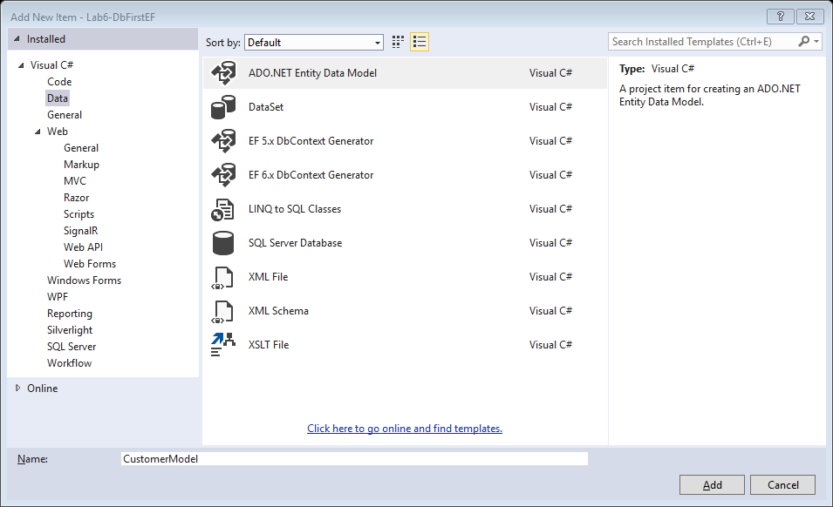

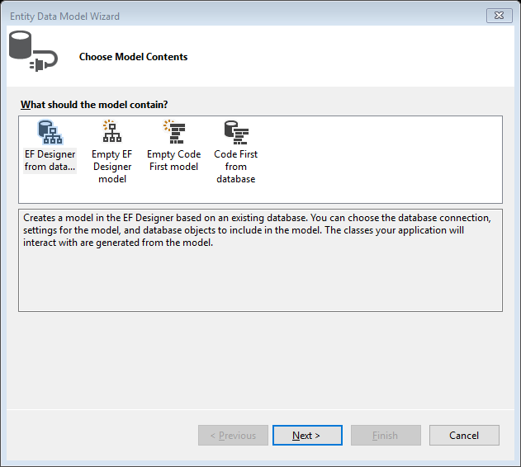

*Select EF Designer from Database and click Next*

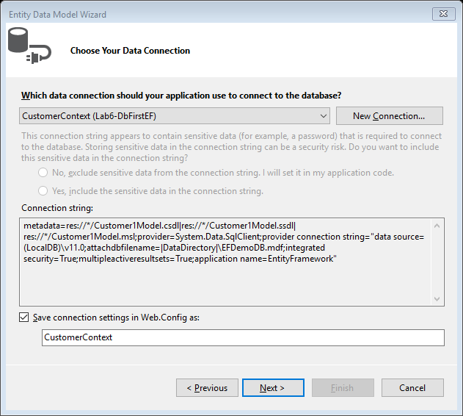

*Enter Context Name and click on Next*

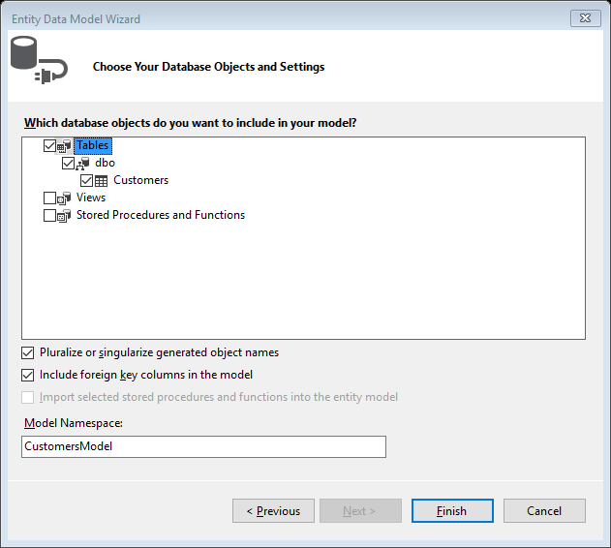

*Select Customer Table > change model Namespace name to CustomersModel and click Finish.*

*Build the solution.*

*Add Controller: Right click on the Controllers folder in the solution explorer > Add > Controller*

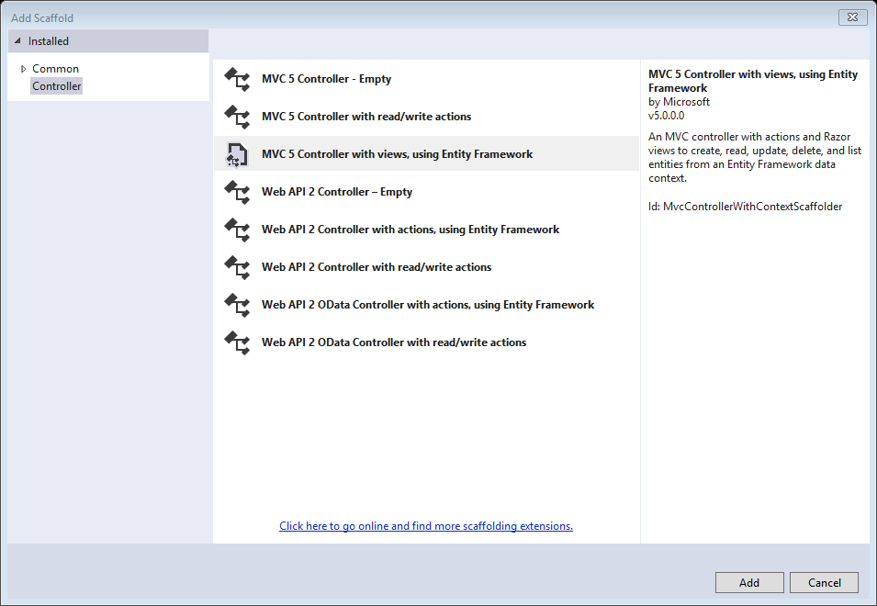

*Select MVC 5 Controller with views, Using Entity Framework > Click Add button*

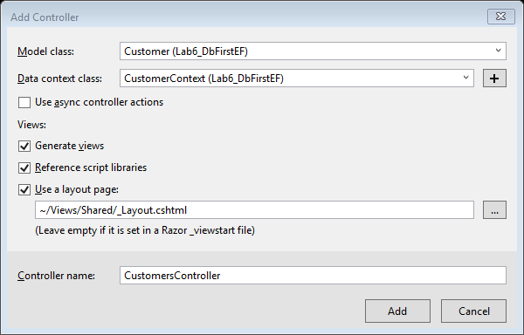

*Select Customer in Model Class > CustomerContext in Data Context class > Controller Name = CustomersController > click on Add*

*Make the following modification in the _Layout.cshtml file*

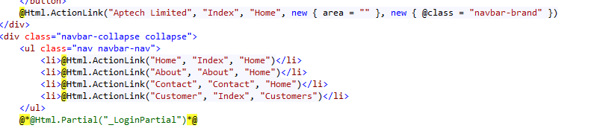

*The application is ready to use.*

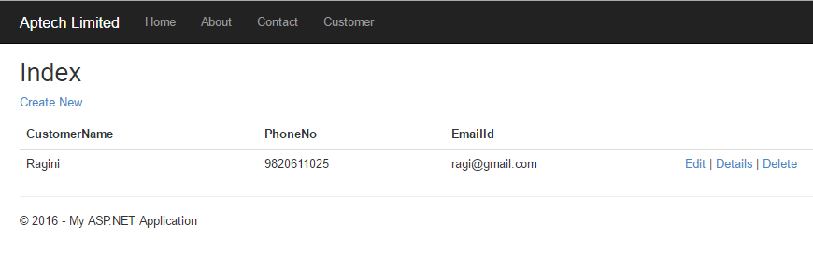

*When we click on the Details link the URL looks as follows:*

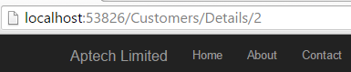

*If we need to make the URL more nice. We a new feature launched in MVC 5 called Rout Attribute.*

*Goto CustomersController, Details Action Method and make the following modifications:*

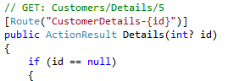

*Goto AppStart Folder > RouteConfig.cs and add the following code:*

**

*Build the code and execute. The URL will look as follows:*

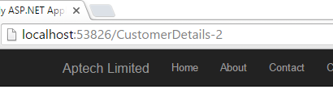

*Now we shall implement the Search option using Stored procedure:*

*Step 1: Goto Index.cshtml and add the search form:*

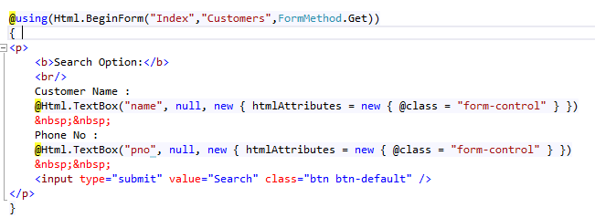

*Step 2: Add a procedure named SearchCustomer in the database:*

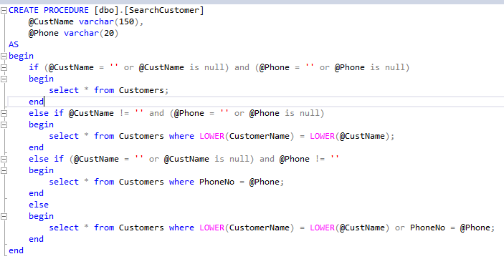

*Step 3: Go to CustomerModel.edmx > Go to Model Browser > Right click and select Update model from Database.*

*Step 4: Go to properties window of SerchCustomer, Function Imports and change the return type as shown below and click OK*

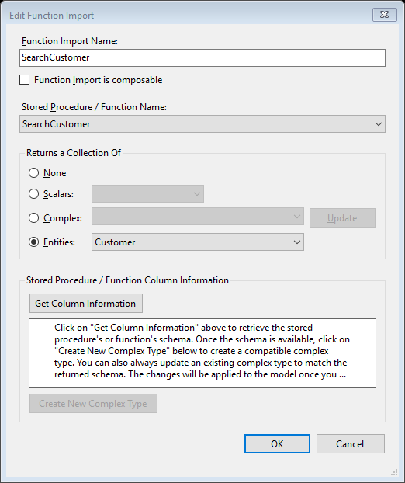

*Step 5: Make modification in the CustomersController in the Index Action method:*

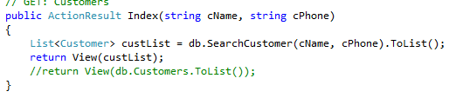

*Now the output will look like:*

